

**Clinical Referral Process**

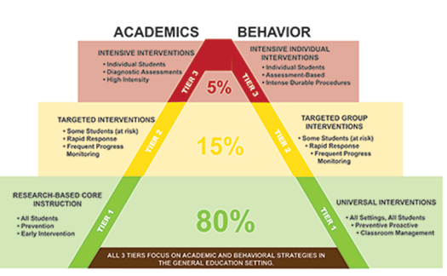

TIER 1

**Universal Classroom Instruction:**

* Student self-managed instruction
* Peer Mediated Instruction
* Classroom screening 3 to 4 x’s per year
* Failure to meet academic/behavioural expectations indicates need to move to Tier 2
* Resource Teacher consults with Classroom Teacher to support the whole class: i.e. ‘Classroom Profile’

Tier 1



**Small Groups:**

* Some basic and higher instruction
* Explicit instruction in basic skills
* Strong instructors or scripted programs with trained instructors
* Could last from 12 to 20 weeks
* Parents should be notified
* Students should have an Adapted Education Plan

TIER 2

Tier 2

**Clinical Consultation**

* Could occur to help identify Tier 2 intervention
* **Note! Tier 1 data collection needs to occur before consultation**
* See Case Management work sheet to aid in data collection and determining next steps
* Student is identified (data is collected)
* Teacher consults with resource
* **Resource Teacher acts as a case manager**
* **School team selects a tier 2 intervention**

**Individualized:**

* Smallest groups or paired instruction
* Expert instruction
* Very basic skills
* Lasting 20 weeks or longer
* Weekly progress monitoring
* Parents should be notified
* Student will have a formal Individual Education Plan
  + Curricular outcomes may be modified

TIER 3

Tier 3

* Case manager consults with school team



* Progress is reviewed
* A Tier 3 intervention is selected

**SUMMARY re: Accessing Student Services**

* Classroom assessment information, cumulative records, and observations indicate a student has not responded to universal classroom instruction (Tier 1)
* A case manager is appointed (resource teacher)
* A tier 2 intervention is selected i.e. ‘reading recovery’; EIR etc. Clinical consultation could be involved in selecting tier 2 interventions
* Failure to respond to Tier 2 interventions would involve a Tier 3 intervention
* Failure to respond to either Tier 2 or Tier 3 interventions could involve a pre-consult with a clinician, contact with the student services coordinator, and a formal referral for a clinical assessment

**Clinical Assessment**

* Pre-consult with a clinician occurs
* Student Services coordinator is contacted
* A referral for clinical services is completed
* A student could be referred for a clinical assessment after failing to respond to Tier 2 or Tier 3 interventions

**Note!** In some cases a review of information will indicate that tier 2 or even tier 3 interventions may have occurred before school entry. In these cases clinical assessment may occur (if available) prior to additional school intervention in order to inform school programming.

**The following RTI referral process applies to the disciplines of Psychology; Speech and Language, Behaviour Support**