Explanation of Psychological Testing theory (CHC; Cattell; Horn; Carol)
Broad Areas of Intellectual Development related to Academic Achievement (5 of 7)

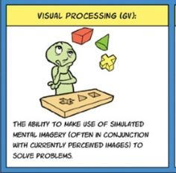 | 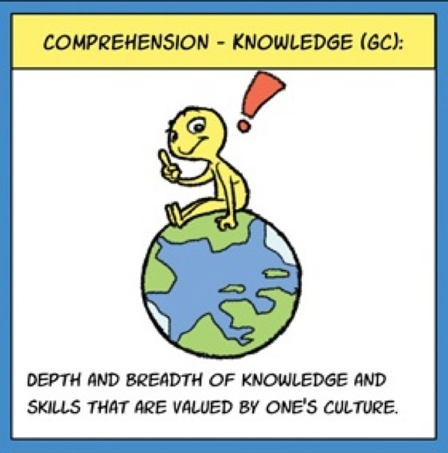
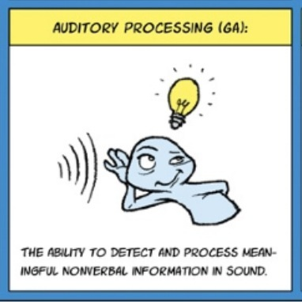 | 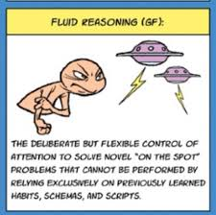
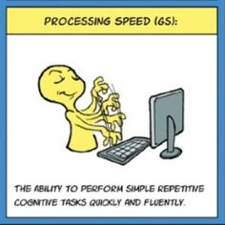

Cognitive Ability and Definition | It’s like… | What This Could Generally Look Like | What You Might Specifically See  at Home or School
Crystallized Knowledge:  An individual’s amount of knowledge of their own culture. | The brain’s “library,” where learned information is stored. Some libraries are bigger and have many materials while others are smaller and have fewer materials. | Difficulties/Strengths with:  - Learning new information  - Understanding the words people use when speaking  - Remembering facts  - Using appropriate words when talking | Difficulties/Strengths with:  - The amount of words they use and understand (vocabulary)  - Understanding what they are reading  - Understanding math concepts  - Following the rules of writing (grammar)  - Creative writing  - Understanding class lessons
Fluid Reasoning:  An individual’s ability to solve problems with new information. | The brain’s “detective,” that helps to examine clues, draw conclusions, and solve new problems. Some detectives are able to solve problems just by thinking about them, while others solve problems by asking questions and looking at real things. | Difficulties/Strengths with:  - Solving unfamiliar and/or complex problems  - Thinking about new situations  - Learning something in one situation and being able to use that knowledge in a different situation | Difficulties/Strengths with:  - Figuring out the main idea from a reading passage  - Drawing conclusions in reading, math or science  - Understanding math word problems or science concepts  - Understanding the process of completing a math problem  - Explaining how ideas are the same or different when writing and coming up with a conclusion  - Developing a theme when writing
Auditory Processing:  An individual’s ability to hear and use orally presented information. | The brain’s “drive-through attendant” who hears a customer’s message through a speaker system, interprets it, and then performs an action based upon that message (i.e., they enter a food order into a computer system). There can be error in the food ordering process if a message is misheard. | Difficulties/Strengths with:  - Correctly hearing oral information  - Hearing differences between similar sounds  - Paying attention in places where there is background noise  - Figuring out which direction a sound is coming from | Difficulties/Strengths with:  - Breaking words into smaller letter sounds  - Blending letter sounds to make a word  - Sounding out words  - Reading word problems  - Spelling  - Note taking  - Doing high-quality writing
Visual Processing:  An individual’s ability to use visual information. | The brain’s “photographer,” who is able to take images, store them on a memory card and “Photoshop” them if needed. Some photographers can take more detailed pictures, store more on a memory card, and change the way a photo looks more than others. | Difficulties/Strengths with:  - Recognizing patterns  - Attending to fine visual details  - Remembering visual information  - Organizing visual information  - Visualizing (i.e., holding a picture in your “mind’s eye”)  - Seeing the difference in how objects look (e.g., size, location, position)  - Imagining how something might look when it is changed (e.g., rotated, partially covered, changed in size)  - Memorizing and using letters, words, and word patterns (e.g., -tion, -ing) | Difficulties/Strengths with:  - Recognizing whole words (i.e., sight words)  - Reading or writing without changing the order of letters in a word or making reversals  - Reading and interpreting maps, graphs, tables, charts, and blueprints  - Planning and organizing visual information on a page (e.g., aligning numbers when doing math problems)  - Building puzzles  - Using patterns and designs in art, geometry or geography  - Spelling sight words  - Writing with appropriate size, spacing, and slant of words
Processing Speed:  An individual’s ability to complete simple tasks quickly and correctly. | The brain’s “internet speed.” Some people have processing speed that would be similar to dial-up internet (slow to process information) while others have speed similar to internet provided through fiber optic cables (quick to process information). | Difficulties/Strengths with:  - Completing simple tasks quickly and correctly  - Working within a time limit  - Making quick decisions | Difficulties/Strengths with:  - Reading at a good pace (which affects understanding)  - Quickly answering math fact questions  - Efficient written output  - Motivation to produce writing  - Getting thoughts across quickly when talking

Explanation of Psychological Testing theory (CHC; Cattell; Horn; Carol)
Broad Areas of Intellectual Development related to Academic Achievement (2 of 7)

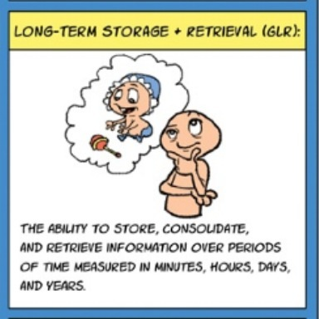 | 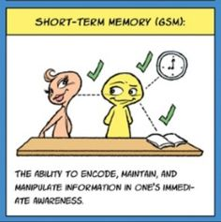

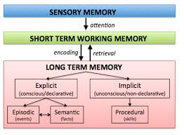
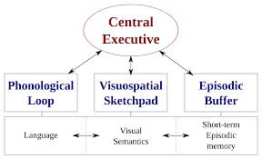
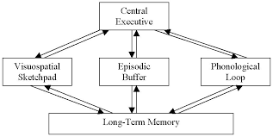

Cognitive Ability and Definition | It’s like… | What This Could Generally Look Like | What You Might Specifically See  at Home or School
Short-Term/Working Memory:  An individual’s ability to hold information in mind and use this information within a few seconds. | The brain’s “post-it note,” where messages are temporarily placed and then thrown out after being used. Some people are able to write a lot of information on their post-it notes, while others write just a few messages. | Difficulties/Strengths with:  - Remembering complex instructions (i.e., more than one)  - Following through with multi-part instructions  - Multi-tasking  - Remembering a sequence of information  - Memorizing information  - Keeping a train of thought | Difficulties/Strengths with:  - Sounding out longer words when reading  - Spelling longer words  - Understanding and remembering what they are reading  - Memorizing math facts  - Remembering the process of completing a math problem  - Figuring out the main information from a math word problem  - Note taking
Long-Term Memory/Retrieval:  An individual’s ability to store information in memory and use it in the future. | The brain’s “vault” or “safe,” where information is kept. Some vaults have complex security systems (and take more effort to access), but some only have simple access codes. They also vary on how big and organized they are. | Difficulties/Strengths with:  - Learning new concepts  - Recalling specific information  - Learning and recalling information quickly  - Remembering information without repetition or review | Difficulties/Strengths with:  - Using personal experiences to help with understanding new reading passages  - Remembering the specific sounds that letters make when reading  - Summarizing what they have read  - Recalling math facts  - Thinking of words and ideas to use when writing or talking

Psychological Skills Measured in Psych Assessments that predict School Achievement
Seven Broad Thinking Skills and Two Areas of Executive Functioning

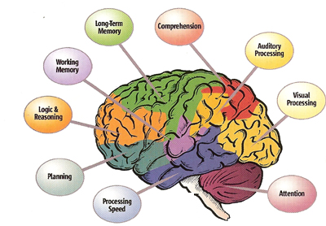

Note!
- Student with skills Below Average and student in the Low range of intellectual functioning will be required to complete regular academic outcomes and not have the IEP box checked off on the report card
- Students in the Low range of intellectual functioning while not considered Intellectually Disabled may present as ‘Slow Learners’ and benefit from an IEP
- Students in the Extremely Low Range of Intellectual and Adaptive Functioning meet diagnostic criteria for Significant Cognitive Disability/Intellectual Disability and are eligible to have the IEP box checked off on their report and can receive curricular modifications as needed
  - As an approximated guideline:
    - Students with an IQ ranging 50 to 70 often achieve grade 4 to 6 level reading outcomes
    - Students with an IQ below 50 may have difficulty achieving beyond an elementary level of academic outcomes

Eight Common Executive Functions related to Academic Performance:

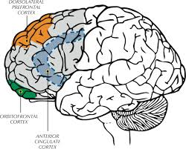

Executive Function and Definition | It’s like… | What This Could  Generally Look Like | What You Might Specifically See  at Home or School
Planning:  An individual’s ability set goals and make up steps to finish tasks. | The brain’s “coach” or “personal trainer,” who helps you set personal goals and makes sure the goals are possible to complete. | Difficulties/Strengths with:  - Setting goals  - Developing timelines to meet a goal  - Understanding the time needed to finish a task and how hard the task will be  - Making good decisions or thinking through decisions | Difficulties/Strengths with:  - Bringing homework, assignments, and materials home  - Handing in homework when it is done  - Studying over time to get a good grade  - Managing projects with more than one step  (e.g., draw, cut, then paste)  - Doing things in order  - Saving money for a special item  - Dressing for the weather
Initiation:  An individual’s ability to start tasks or activities on their own. | The brain’s “jumper cables.” When attached to the right place on the battery, these cables give you the ‘spark’ you need to get going. | Difficulties/Strengths with:  - Knowing where to begin a task and how to get started  - Beginning a task when needed  - Coming up with ideas and solving problems without help  - Putting plans into action | Difficulties/Strengths with:  - Starting assignments without being asked  - Coming up with ideas for what to do during recess  - Coming up with ideas for what to write  - Setting a specific time to do a task  - Starting conversations with others  - Organizing activities with friends  - Taking on new projects
Organization:  An individual’s ability to manage their thoughts, work materials and belongings. | The brain’s “storage bins,” which help to organize all the things that you need. | Difficulties/Strengths with:  - Setting up work and storage areas in a certain way  - Managing time  - Working neatly  - Having work materials and belongings handy  - Clearly sharing thoughts  - Managing many tasks at once | Difficulties/Strengths with:  - Keeping papers and notebooks organized  - Keeping desks, lockers, backpacks and bedrooms neat  - Caring for items without losing them  - Tracking the due dates for homework and assignments and finishing on time  - Completing one task before starting a new one  - Bringing home school newsletters  - Following directions to make a simple recipe
Attention:  An individual’s ability to keep focused without getting distracted or quitting. | The brain’s “runner.” Some people are long distance runners (they can pay attention for a long time), while others are better at running short distances (they pay attention for a short time). | Difficulties/Strengths with:  - Staying on-task, even when bored or tired  - Having attention to detail  - Working in a noisy environment  - Finishing tasks  - Focusing on one thing | Difficulties/Strengths with:  - Working on projects that are long, involve a lot of sitting, or not enjoyable  - Finishing tasks without rushing or making careless mistakes  - Reading a book or listening to one being read for a long time  - Concentrating while reading  - Staying on topic when talking  - Listening closely to instructions
Self-Monitoring  An individual’s ability to watch what they are doing and how they are doing it. | The brain’s “security camera,” which is able to take a video of everything that is happening, and make sure that everything is safe and going okay. | Difficulties/Strengths with:  - Knowing what things are easier for them to do and when to ask for help  - Figuring out what still needs to be done to finish a project  - Noticing and fixing mistakes  - Learning from mistakes  - Knowing when a task in finished | Difficulties/Strengths with:  - Checking work for mistakes and correcting errors  - Trying all problems on assignments or tests (not accidentally missing any)  - Seeing how their behavior affects others  - Being on time for class  - Keeping track of time and assignment deadlines  - Giving each part of a project enough time to be done well
Flexibility/Shifting:  An individual’s ability to easily move from one task to another and/or change plans when needed. | The brain’s “gear shifter,” which helps the driver change their speed while driving. Sometimes the driver needs to speed up or shift down when road conditions change (e.g., passing on a highway, driving in a construction zone). | Difficulties/Strengths with:  - Switching from one activity to another  - Being okay with changes of routine  - Having lots of ideas of how to do things  - Changing a plan that is not working  - Solving a problem in different ways | Difficulties/Strengths with:  - Trying different ways to solve a math problem when the first idea does not work  - Switching their attention from a worksheet to the teacher talking  - Coming up with ideas for writing a story (brainstorming)  - Working with a second choice or a change in plans (e.g., when a friend is sick and a play date is cancelled)  - Accepting a different way of doing things
Control of Behaviour:  An individual’s ability to stop and think before acting. | The brain’s “police officer,” who reminds you of the rules and helps to keep you out of trouble. | Difficulties/Strengths with:  - Thinking before acting  - Waiting to get what they want  - Knowing how they are supposed to act and being able to do it  - Keeping a promise or commitment | Difficulties/Strengths with:  - Putting their hand up when they want to say something in class  - Calmly waiting for a turn to play in gym class  - Staying at their desk instead of walking around the classroom  - Finishing a task that takes a long time  - Working well without adult help  - Following school rules, even if it might seem more fun not to  - Cooperating with classmates or teachers
Control of Emotions  An individual’s ability to know how they are feeling and to manage those feelings. | The brain’s “therapist,” who helps you to understand how you are feeling and teaches you ways to handle things that happen. | Difficulties/Strengths with:  - Handling their emotions in different situations (e.g., staying calm when stressed, reacting well to surprises)  - Handling disappointment  - Waiting patiently and handling delays | Difficulties/Strengths with:  - Handling the stress of a test  - Solving problems with friends/classmates by working together  - Using strategies to calm down (e.g., stopping to breathe or taking a break)  - Staying calm if plans are changed, things do not work out or in a new situation

