K | 1 | 2 | 3 | 4 | 5
Knows number names and the count sequence  Numberfly(NI), MIND, Acadience, K5 Learning, have student count aloud  FAM | Represent and solve problems involving addition and subtraction  Cafe, MIND, Fact Families, | Represent and solve problems involving addition and subtraction within 100 in word problems  K5 Learning, MIND, Cafe, Acadience, K5 Fact Families | Represent and solve problems involving multiplication and division  Cafe, K5 Mult, K5 Div, MIND Mult, MIND Div, Acadience, Delta, CC, Cafe WP | Use the four operations with whole numbers to solve problems  K5 Learning, K5 Operations, Cafe, Cafe WP | Understand the place value system  K5 Learning, Math Aids, CC
Count to tell the number of objects  Object Counting, K5 Learning, MIND, p.32/33, Cafe, have student count paperclips/objects  FAM | Understand and apply properties of operations and the relationship between addition and subtraction  MIND, Fact Families, Cafe, Ten-Frames  FAM | Add and subtract fluently within 20  MIND add, MIND sub, Cafe, Acadience, Education, p.38  WIAT, WJ, FAM | Understand properties of multiplication and the relationship between multiplication and division  K5 Mult, K5 Div, K5 Fact Families, MIND Relationships, Cafe  FAM | Generalize place value understanding for multi-digit whole numbers  K5 Place Value, MathAids | Perform operations with multi-digit whole numbers and decimals to hundredths  K5 Decimals, Decimals
Compare numbers  Numberfly(QD), Acadience, p.31, numeracy  FAM | Add and subtract within 20  Cafe, MIND add, MIND sub, Education, Ten-Frames, Delta, Acadience, p.37  WIAT, WJ, FAM | Understand place value  K5 Learning, MathAids, CC | Multiply and divide within 100  K5 Multiplication, K5 Division, Cafe, Delta, p.38, Cafe2  WIAT, FAM | Use place value understanding and properties of operations to perform multi-digit arithmetic  K5 Learning, Cafe | Use equivalent fractions as a strategy to add and subtract fractions  K5 Fractions, Fractions
Understand addition as putting together and adding to, and understand subtraction as taking apart and taking from  Number Line, Fact Families, Cafe, MIND  FAM | Work with addition and subtraction equations  K5 Learning, MIND, Fact Families, Cafe, Acadience | Use place value understanding and properties of operations to add and subtract  K5 Learning, MathAids, Cafe, Education | Solve problems involving the four operations, and identify and explain patterns in arithmetic  K5 Operations, K5 WP, Skip Counting, Delta, Cafe | Extend understanding of fraction equivalence and ordering  K5 Fractions, Delta | Apply and extend previous understandings of multiplication and division to multiply and divide fractions  K5 Fractions, SuperKids
Work with numbers 11-19 to gain foundations for place value  Number Line, Ten-Frames | Extend the counting sequence  Numberfly(MN), K5 Learning, Number Line, Acadience  FAM | Measure and estimate lengths in standard units  MWSS, K5 Learning, CC | Develop understanding of fractions as numbers  K5 Fractions, Delta, CC | Build fractions from unit fractions by applying and extending previous understandings of operations  K5 Fractions, Delta | Geometric measurement: understand concepts of volume and relate volume to multiplication and to addition  K5 Measurement, Volume
 | Understand place value  K5 Learning, MathAids | Relate addition and subtraction to length  K5 Learning, MWSS, Cafe | Solve problems involving measurement and estimation of intervals of time, liquid volumes, and mass of objects  K5 Measure, K5 Time, Time, Measure, CC, Cafe, Cafe2, Mass | Understand decimal notation for fractions, and compare decimal fractions  K5 Learning, CC | Graph points in the coordinate plane to solve real-world and mathematical problems  Graphing, CC
 | Use place value understanding and properties of operations to add and subtract  K5 Learning, Cafe |  | Geometric measurement: understand concepts of area and relate area to multiplication and addition  K5 Learning, CC
Measure lengths indirectly and by iterating length units

K5 Learning, MWSS, use a ruler/measuring tape
Instructional Hierarchy Rules of Thumb: Grades 1-3: Acquisition Phase 0-19 correct digits per 2 minutes, Fluency Building Phase 20-39 per 2 minutes, Mastery 40 per 2 minutes
Grades 4-6 double the above, Grades 7+ add 20%

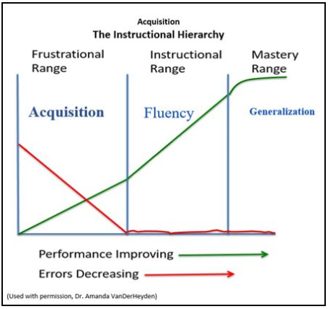
- Instructional Hierarchy Acquisition strategies: Explicit and systematic instruction, multimodal
presentations, active demonstration of target skill, modeling of correct performance, close
supervision with immediate feedback. cover-copy-compare, peer tutoring

- Fluency building strategies: Increased opportunities for practice and opportunities to respond,
delayed feedback, independent practice, daily practice, incremental rehearsal, TCCC,
self-monitoring, folding in, flashcards, drill sandwich, timed trials, TP (video), drills

- Available/Approved Math Interventions: First in Math (Supplemental), Do the Math (K-5), Bridges
(Title 1 - Elem), Dreambox Learning (Title 1 - Elem), Math 180 (Middle)

- Additional Instructional Resources: p.138, XtraMath (basic operations practice), Freckle (broad
math), MIND (early numeracy and basic operations), Splash (skill specific), ThatQuiz (skill practice),
Pirate (word problems), computer flashcards by grade, SOM, games, Common Core Standards, IES fractions,
IES intervention, IES problem solving, mathigon, major standard clusters, fluency practice

- Progress monitoring, with norms/benchmarks: easycbm, acadience, delta, intervention central,
MIND, iReady, intervention central2, Fuchs, p.31, AACPS Checkpoints, numeracy

- Possible Report Recommendations

